**Project Development Phase**

Sprint-2 Create Service Instance

|  |  |
| --- | --- |
| Date | 04 November 2022 |
| Team ID | PNT2022TMID2564 |
| Project Name | Virtual Eye - Life Guard For Swimming Pools To Detect Active Drowning |
| Maximum Marks | 8 Marks |

* Log in to your IBM Cloud account, and click on Catalog
* Type Cloudant in the Search bar and click to open it.

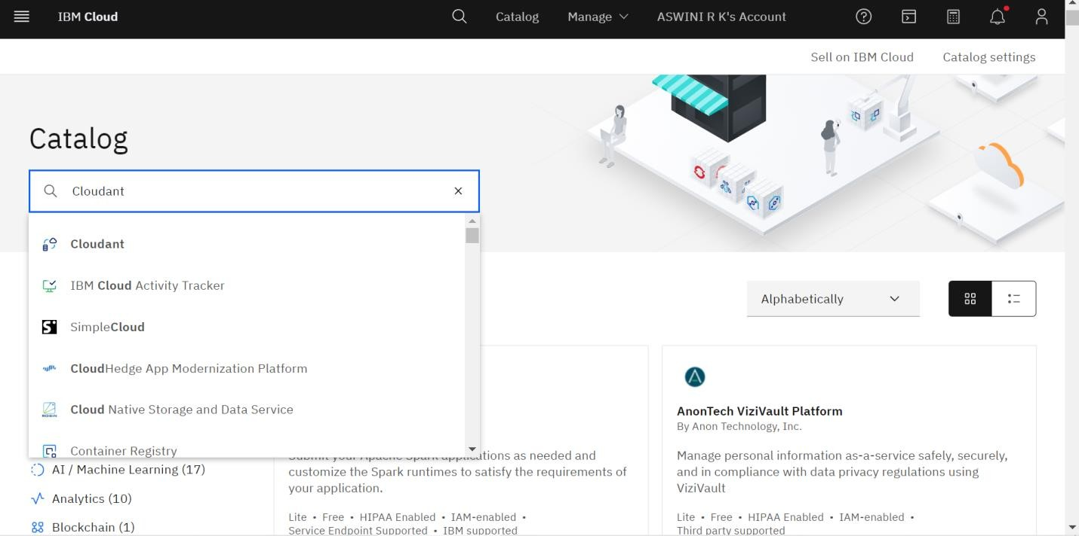

* Select an offering and an environment
* Select region as Dallas & Type an instance name then click on create service.

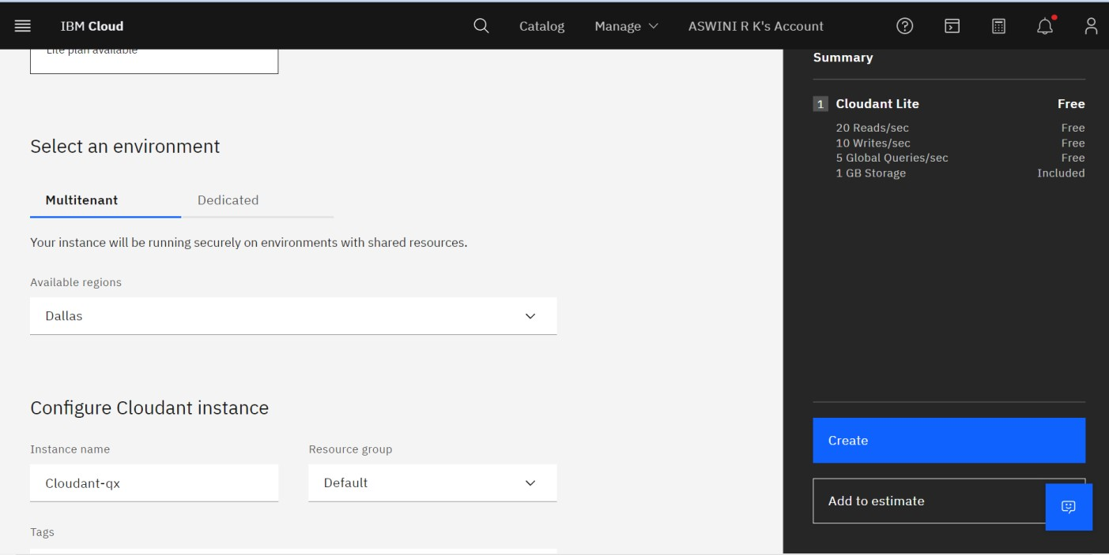

* The status is changed to Active and then click the instance.

